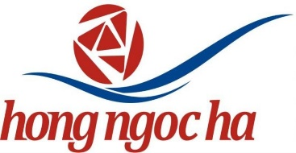


ETICKET & BOOKING INFORMATION

eTicket Receipt
Prepared For
LY/THI THU HUONG
Reservation Code | LHBRFE
Issue Date | 21Jan2014
Ticket Number | 7382446101811
Issuing Airline | VIETNAM AIRLINES
Issuing Agent | Vietnam Airlines/AE0

Itinerary Details
Travel Date | Airline | Departure | Arrival | Other notes
21Jan | VIETNAM AIRLINES  VN 1425 | PLEIKU, VIETNAM  Time  18:20 | HO CHI MINH CITY, VIETNAM  Time  19:35  Terminal  TERMINAL 1 | ClassEconomy  Seat NumberCheck-in Required  Baggage Allowance20K  VCR StatusOK  Fare BasisLPX  Not Valid Before21 Jan  Not Valid After21 Jan

Payment/Fare Details
Form of Payment | Travel Bank : XXXXXXXXXXXX 0003
Endorsement / Restrictions | NON-END. REST MAY APPLY/CONTACT VN OFF B4 FLT DATE/ONLINE
Fare Calculation Line | PXU VN SGN1200000LPX VND1200000END
Fare | VND 1,200,000.00
Taxes/Fees/Carrier-Imposed Charges | VND 120,000.00 UE (Value Added Tax)
 | VND 50,000.00 AX (Domestic Passenger Service Charge)
Total Fare | VND 1,370,000.00

